Chris House

ENC1101

Professor Garcia

October 30, 2021

Keeping a Balance of Education and Entertainment: an Analysis of the Video Essay Genre

When you hear the term “video essay”, what comes to mind? Maybe a long winded and drawn out speech by a dry speaker, or a monotone lecture by a professor? In any case, video essays don’t seem like entertaining videos to watch, partly due to the “essay” part of the name. However, under the right circumstances, a video essay can be extremely entertaining while also educating you the same way that an academic essay does. Video essays are much more flexible than a standard written essay or even a documentary, which means it’s up to the person making them (the “producer” or “rhetor”) what kind of rhetorical devices are used, what tone the essay is in, and how the producer makes the essay interesting and entertaining. To this end, two different video essays on the same topic could be wildly different and have different rhetorical situations, yet convey similar meaning. As the authors of *Writing about Writing* states “Like maps, genres aren’t rigid and formulaic.”(page number). The video essay genre is a perfect example of this statement: even two different essays from the same rhetor could be very different. This makes the video essay genre both difficult and fun to analyze, since there’s so much variation between different video essays. This is also what makes the video essay genre so successful, it appeals to a wide group of rhetors, as they can make a video essay with the exact tone that they want, while still benefiting from the effects of the video essay genre.

The video essay genre is a fairly new one, with the first videos classified as video essays being created in the early 2010s. This lends to some ambiguity in the description of a video essay, though most of the general characteristics are common among all descriptions of the genre. The most basic description of a video essay is “an academic essay in video form”, though that description is vague and doesn’t get to the heart of the genre. Generally, video essays try to educate the desired audience while also keeping their attention by providing entertaining graphics that wouldn’t be possible in a typical written essay.

In order to fully understand the genre, we must first look at the general structure of a video essay. Most video essays follow a similar idea: a video that explains a topic in an educating and entertaining way, usually with a discernible structure similar to that of a written essay. Depending on the topic, however, the essay can have wildly different characteristics. If the producer is talking about a particular event or person, there may be a chronological order to the video, with different sections dedicated to a part of the timeline. For instance, if a producer was making a video about a company that had gone defunct, the producer would split the video into three or more sections: the beginning and the rise of the company, their peak, and their downfall. This gives a nice arc that can easily be tied up at the end. If the producer is talking about a new technology, they might give an introduction with some background info about the technology, three or more points about what makes the technology important, then a conclusion that brings everything together in the last section. This all depends on the topic and the rhetor, however, as the video essay genre gives the producer a lot of freedom in terms of structure.

However, the video essay genre is not about giving rhetors complete freedom. The structure, while very free flowing, is usually clearly defined in a video essay, with the inclusion of discernible sections in the video. They act as the paragraph breaks in the essay; they give time for the viewer to reflect on the previous information, and give a good idea of what the next section is about. A good video essay will provide a transition or conclusion statement at the end of a section, so that the section breaks in a video don’t seem jarring. One of the best examples of this is in some of the video essays created by the YouTube creator “NakeyJakey”. In his video titled, “Rockstar’s Game Design is Outdated”, he analyzes the difference between the design of Rockstar’s early video game titles, and their most recent one, “Red Dead Redemption 2”. He gives a critical look at the way that Red Dead Redemption 2 is designed, and splits his criticisms into three different chapters, with transitions that make the video flow smoothly (see Figure 1). NakeyJakey is what most people who watch him would consider a perfect example of someone who creates video essays. Most of the essays he’s produced has educated the audience or expressed an opinion while entertaining the viewer, been written like a standard written essay, and have influenced other creators of the genre. While he wasn’t the first to write a video essay, he definitely had a profound impact on the genre by making it more entertaining for the viewer. He includes jokes, uses colorful metaphors, and interesting visual aids to prove his point. That is what an ideal video essay should do, entertain, express, and educate, all at the same time.

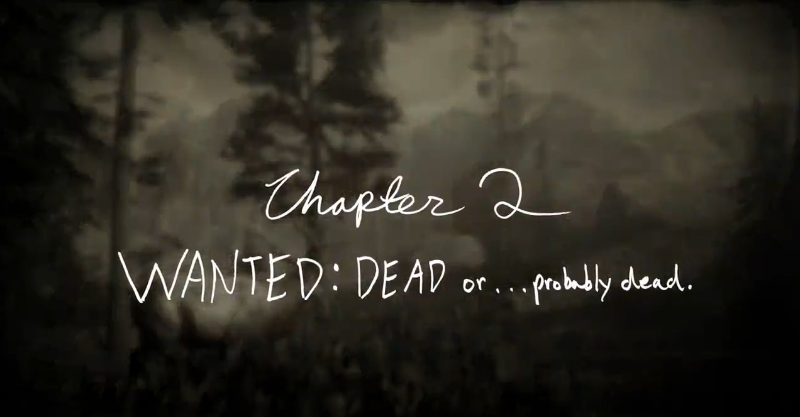Figure 1: Example of Chapter Transitions (13:21)

On the complete opposite side of the spectrum, some video essays are meant educate rather than entertain. For these more academic video essays, the exigence, or how the writers of *Writing about Writing* define it, “the need or reason for a given action or communication.”(page number) is that the rhetor wants a wider reach for their content, so instead of writing a regular written essay, they make a video essay with appealing visual aids to draw the audience in. this next example is a testament to that fact. In a video titled, “The Insane Engineering of the 787”, produced by the YouTube creator “Real Engineering”, the rhetor is trying to explain to someone who may be interested in engineering but doesn’t know a lot about aircraft why the Boeing 787 is a revolutionary airplane. Unlike it’s counterpart I talked about previously, this video essay is much more educational. The tone is very academic, the topic is explanatory rather than argumentative; the rhetor even sites his sources, which is usually something you only see in boring academic papers. However, the rhetor includes visual aids that are appealing to the audience to not only grab their attention but also to supplement the point the rhetor is making (See Figure 2). These visual aids make the video essay stand out more and makes the audience want to watch the content, as opposed to a written essay that may have little or no visual aids and is usually just text. In terms of structure, this video essay example is similar to the previous example that I talked about before, yet it’s different in that the sections are not clearly defined. There are no discernible transitions or chapters like in the previous example, which makes it feel more like a presentation or a speech. It feels very natural and human, which is something you can really say about a faceless written essay. I doubt there’s a lot of people who would want to read an academic paper on the engineering being the Boeing 787, but you turn it into a video essay, and it gets 1.5 million views on YouTube.

Despite the difference between these two very different examples, they are both the same genre. Why? Because they have similar structure, despite having different ways of defining it. They both seek to express a point and entertain the audience at the same time. And they both try to make a much more exciting, engaging, and entertaining essay than something any writer can write up on a piece of paper. This is what makes the video essay genre so appealing to rhetors and audiences. It takes a genre that we all have seen before, and turns it on it’s head by adding a visual element to it. It’s much easier to follow along with somebody talking in a video rather than just seeing their writing on a piece of paper. There’s a human quality to every video essay, which makes each one different. Each video essay is a reflection on the rhetor, a glimpse into how their mind works and how they convey their points to an audience. Being able to hear the tone in the rhetor’s voice, hearing the passion about the topic they are talking about, that is what makes a video essay truly revolutionary and effective. And that, you can never truly capture on just a sheet of paper.